* **Backend**

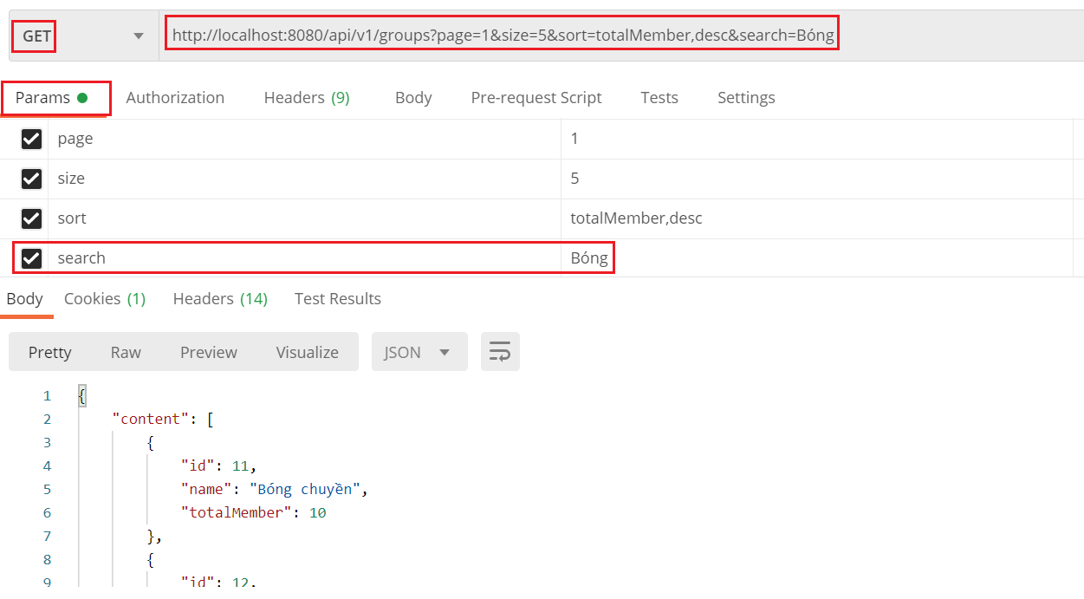

*Đính kèm Token vào header để get groups*

* **Frontend**

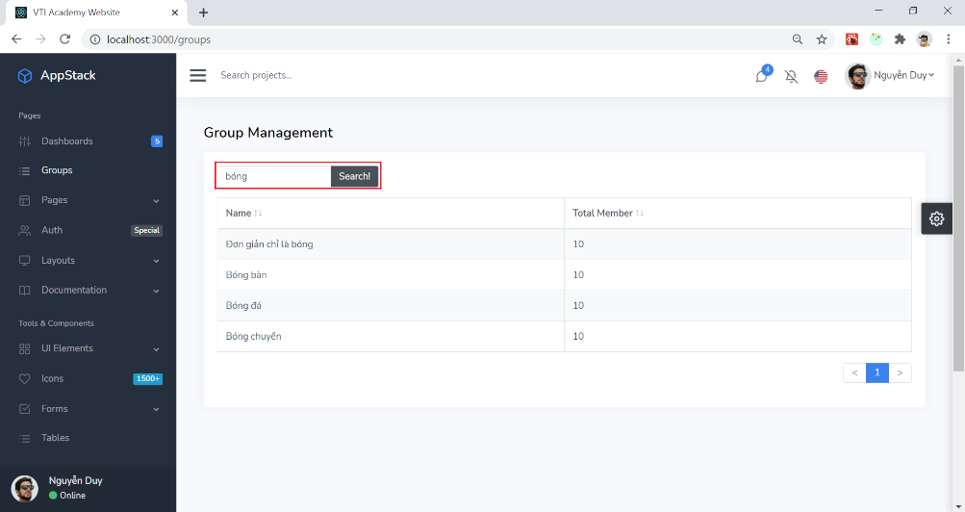

* + Remote Search

<https://react-bootstrap-table.github.io/react-bootstrap-table2/storybook/?selectedKind=Remote&selectedStory=Remote%20Search&full=0&addons=1&stories=1&panelRight=0&addonPanel=storybook%2Factions%2Factions-panel>

* + Basic Search

<https://react-bootstrap-table.github.io/react-bootstrap-table2/storybook/?selectedKind=Table%20Search&selectedStory=Basic%20Search%20Table&full=0&addons=1&stories=1&panelRight=0&addonPanel=storybook%2Factions%2Factions-panel>

* + Custom search

<https://react-bootstrap-table.github.io/react-bootstrap-table2/storybook/?selectedKind=Table%20Search&selectedStory=Fully%20Custom%20Search&full=0&addons=1&stories=1&panelRight=0&addonPanel=storybook%2Factions%2Factions-panel>

* + Enter key event

<https://stackoverflow.com/questions/31272207/to-call-onchange-event-after-pressing-enter-key>

* + Reset page về trang 1
* **Reference**